

Guide for Students to create Attendance Records and have these approved.

Using your username and password that has been created for you go to the Home Page for the site which is https://mycad.ie and enter those details.

We recommend that after you have logged in for the first time you change your password to one that is more memorable to you.
Select ‘Change Password’ on the home page.
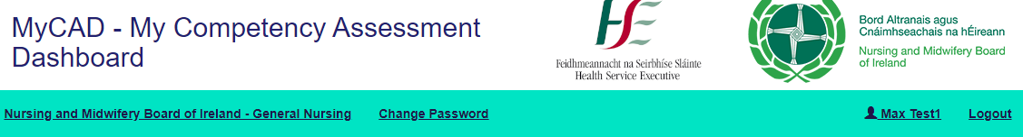
You need to add details of your placement, by scrolling through the list of placements; confirm the type of placement that it is and then create relationships with the Preceptors; Associate Preceptors; Registered Nurses who will be signing off your attendance records and CPC and Link Lecturer that will be supporting you on this placement. You can continue to create these relationships throughout your placement.
By relationship we mean those people who you are allowing to interact with your portfolio, to sign off attendance records.
Please note that if the Preceptors; Associate Preceptors; Registered Nurses details are not there when you search for them, then you will need to ask them to register to create an account. There is a Guide and Youtube video that describes how to do this.
If the details of the Placement you are going to are not in the system, then you can ask your CPC or the Admin team to add these details so you can set up the Placement.
Adding the Placement Details.
Go to the Placement Details section on the Home Page and select ‘Edit Details’. The following page will appear.
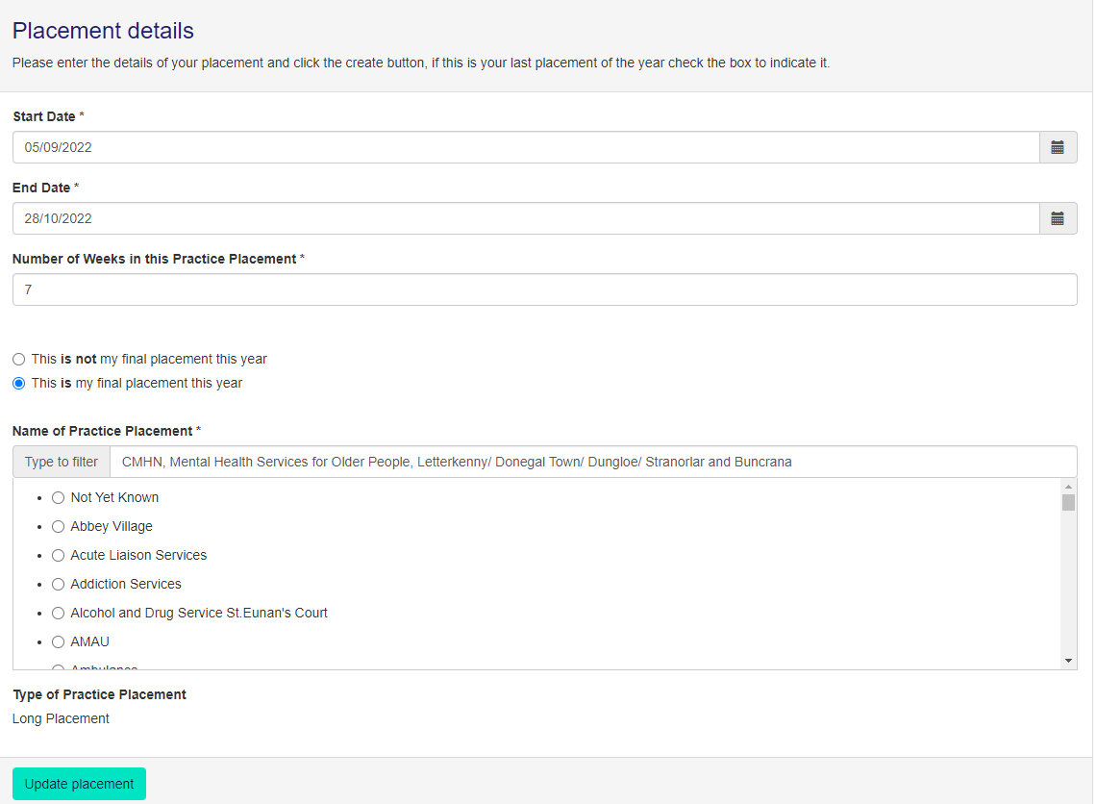
You need to add the Start and End Date for the Placement.
It is then important that you add the correct number of weeks for the Placement. If you unsure add your CPC for advice.
You also need to confirm whether this is the final placement for the year
You can then find your placement either by starting to add the details in Search box at the top of this section or by scrolling through the list.
Then confirm the Placement by selecting ‘Update Placement’
Please note that it is possible to have attendance records for different placements available at the same time but not for the same date period.
Creating the Assessment relationships for this placement.
Each student can have multiple Preceptors/Associate Preceptors/Registered Nurses/Clinical Placement Co-ordinators/Link Lecturers supporting them on a placement.
This is what you see;
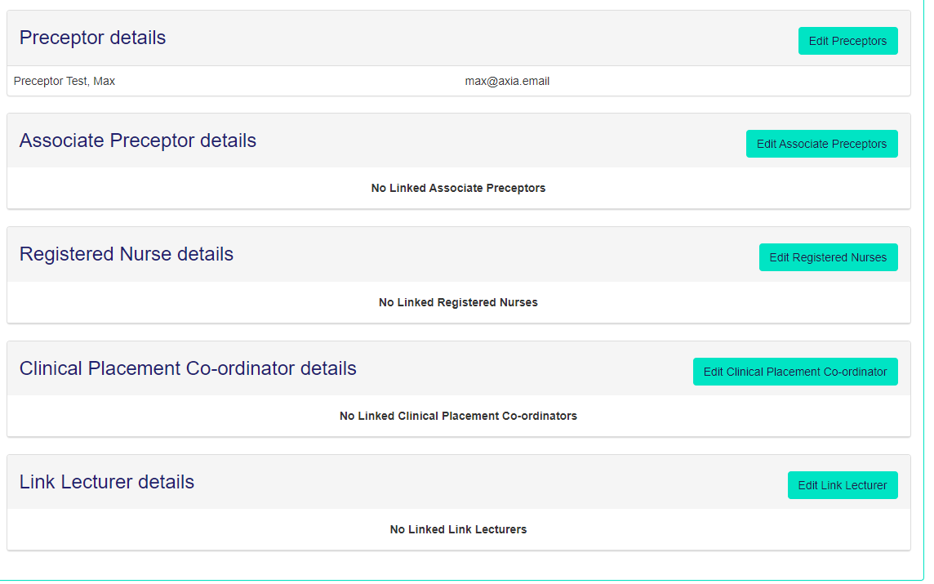
If they then select ‘Edit Preceptors’ they can search for the one you want, but they will only appear if they are registered.
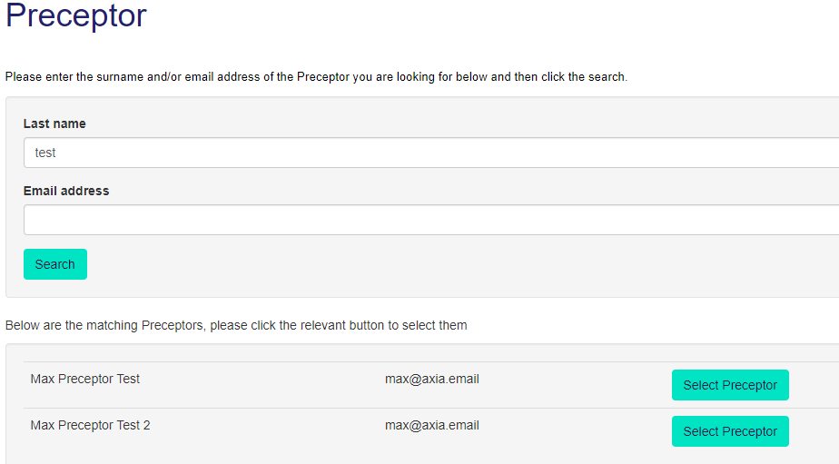

The site then controls what each person can do based on the role they are performing for you on that placement. Until they are selected by you they cannot see your portfolio. Once you select them and they are registered you/they will see the illustration below. The content for the attendance is the same as what you now see when using the paper document.
All the headings that are underlined are links. If you put your mouse on the link then the appropriate page will appear.
This is your student dashboard and you can directly access any page from here. You only need to select ‘Attendance Record’.
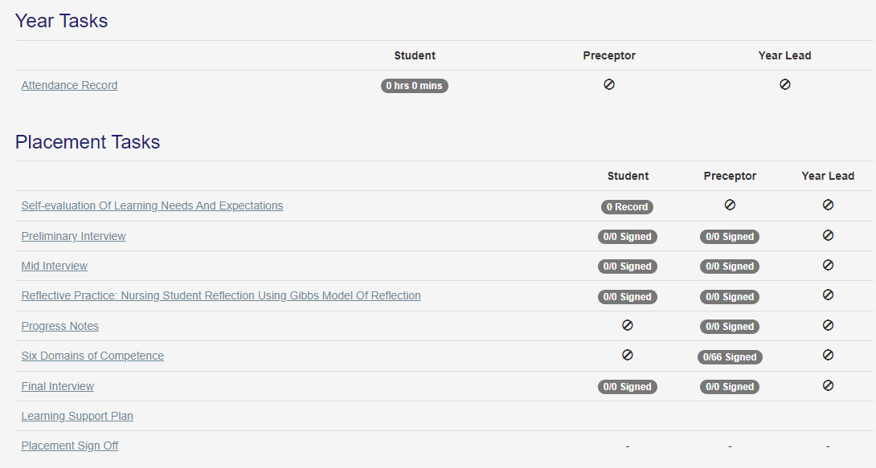

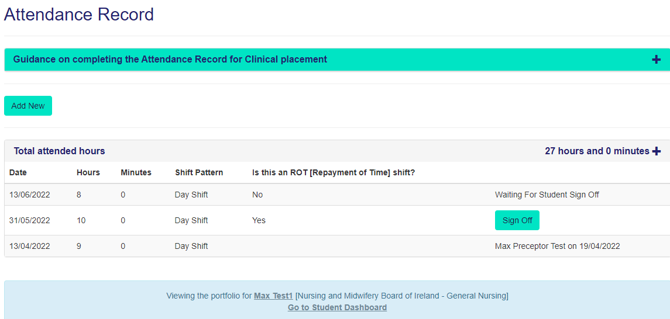
This is what appears when you select Attendance Record. Complete the details of your shift and/or other activity by selecting ‘Add New’. This is what appears.
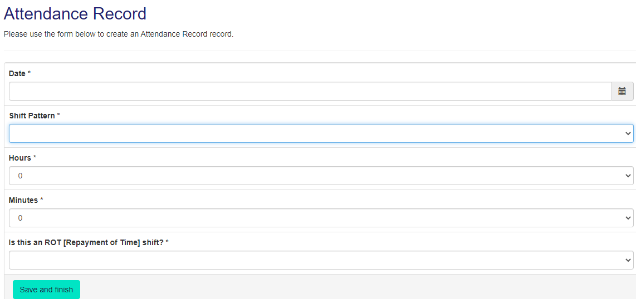
Select the Arrows at the end of the box to choose the correct option for the Attendance Record.
Once you have created your attendance record, Sign it off. The system asks you to double check the record is correct.
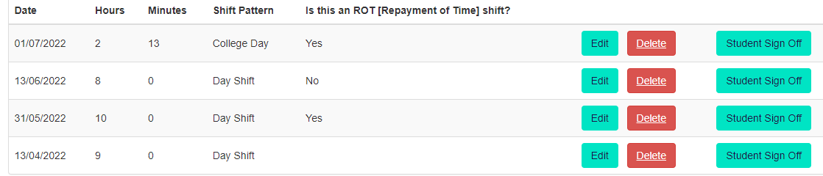
Once you have signed if off the record then becomes available to the Preceptor/Assistant Preceptor/Registered Nurse to sign if off. Once they have done this the ‘Total Attended hours’ will be amended.
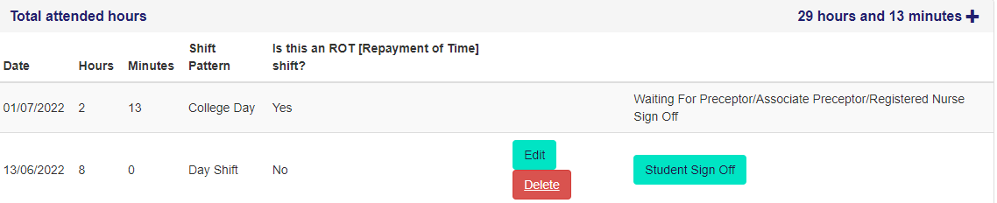
Multiple Placements
Please note the site allows you to have multiple placements open at one time.
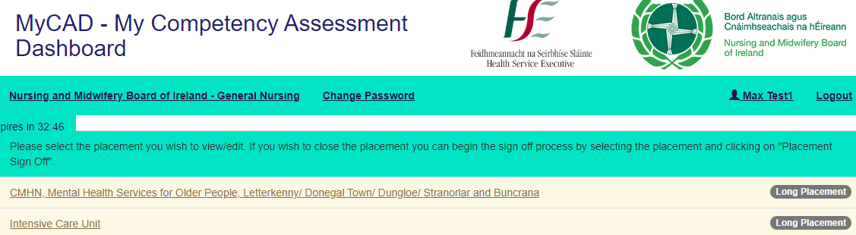
Make sure that when you are adding your placement records that you select to the correct placement.
The Timer.
You will note that at the top of the page there is a Timer which reminds you that as with other secure documents e.g. bank statements you are logged out if there has been no interaction with a page. In the case of MyCAD this is set at 35 minutes, however this timer is reset whenever you have taken an action with the site e.g., moved to a new section or typed in some content.
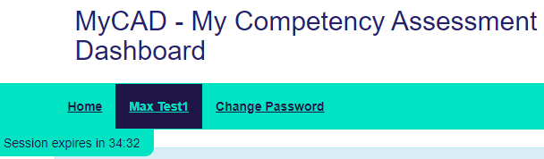

Finally, some top tips;
- You can use any electronic device that is connected to the internet to access the site including your mobile phone.
- Always remember to ‘Save’ whatever content you have added.
- When completing a form together with your Preceptor make sure you both log-in separately. The usual sequence is that the student creates the attendance record and then the Preceptor/Associate Preceptor/Registered Nurse logs in to sign it off. and then log out before the student adds their content/signature or vice versa.
- You can view the whole portfolio by selecting the print icon at the top of the page.
We hope it goes well and welcome any feedback.

